UNITED STATES
SECURITIES AND EXCHANGE COMMISSION
Washington, D.C. 20549
_____________________________________________________________________
SCHEDULE 14A
Proxy Statement Pursuant to Section 14(a) of the
Securities Exchange Act of 1934
_____________________________________________________________________
Filed by the Registrant x
Filed by a Party other than the Registrant ☐

Check the appropriate box:
☐ |  |  | Preliminary Proxy Statement
☐ |  |  | Confidential, for Use of the Commission Only (as permitted by Rule 14a-6(e)(2))
☐ |  |  | Definitive Proxy Statement
x |  |  | Definitive Additional Materials
☐ |  |  | Soliciting Material under §240.14a-12
NAUTILUS BIOTECHNOLOGY, INC.
(Name of Registrant as Specified In Its Charter)
(Name of Person(s) Filing Proxy Statement, if other than the Registrant)
Payment of Filing Fee (Check all boxes that apply):
x |  |  | No fee required.
☐ |  |  | Fee paid previously with preliminary materials.
☐ |  |  | Fee computed on table in exhibit required by Item 25(b) per Exchange Act Rules 14a-6(i)(1) and 0-11.

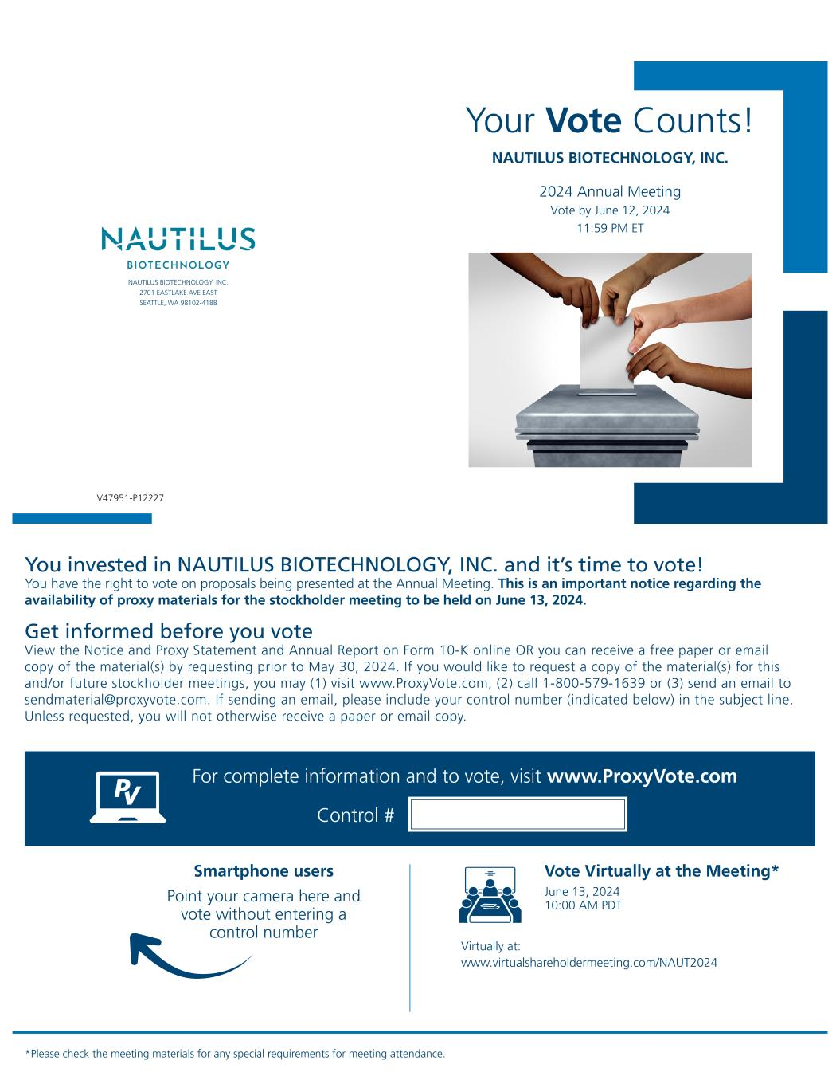

Your Vote Counts! *Please check the meeting materials for any special requirements for meeting attendance. Smartphone users Point your camera here and vote without entering a control number For complete information and to vote, visit www.ProxyVote.com Control # V47951-P12227 NAUTILUS BIOTECHNOLOGY, INC. 2024 Annual Meeting Vote by June 12, 2024 11:59 PM ET You invested in NAUTILUS BIOTECHNOLOGY, INC. and it’s time to vote! You have the right to vote on proposals being presented at the Annual Meeting. This is an important notice regarding the availability of proxy materials for the stockholder meeting to be held on June 13, 2024. Vote Virtually at the Meeting* June 13, 2024 10:00 AM PDT Virtually at: www.virtualshareholdermeeting.com/NAUT2024 Get informed before you vote View the Notice and Proxy Statement and Annual Report on Form 10-K online OR you can receive a free paper or email copy of the material(s) by requesting prior to May 30, 2024. If you would like to request a copy of the material(s) for this and/or future stockholder meetings, you may (1) visit www.ProxyVote.com, (2) call 1-800-579-1639 or (3) send an email to sendmaterial@proxyvote.com. If sending an email, please include your control number (indicated below) in the subject line. Unless requested, you will not otherwise receive a paper or email copy. NAUTILUS BIOTECHNOLOGY, INC. 2701 EASTLAKE AVE EAST SEATTLE, WA 98102-4188

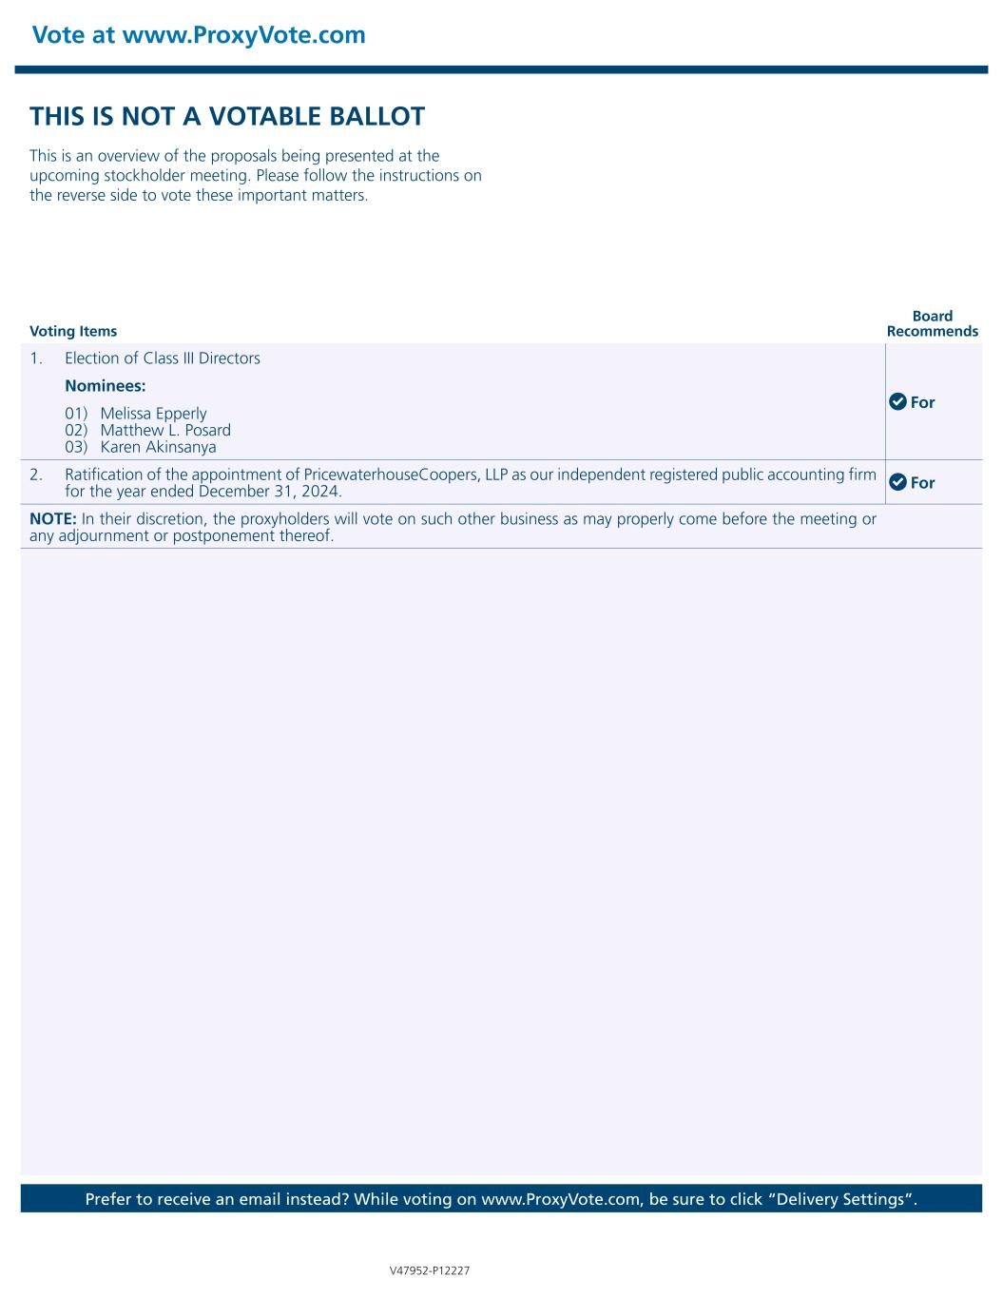
Vote at www.ProxyVote.com Prefer to receive an email instead? While voting on www.ProxyVote.com, be sure to click “Delivery Settings”. V47952-P12227 Voting Items Board Recommends THIS IS NOT A VOTABLE BALLOT This is an overview of the proposals being presented at the upcoming stockholder meeting. Please follow the instructions on the reverse side to vote these important matters. 1. Election of Class III Directors For Nominees: 01) Melissa Epperly 02) Matthew L. Posard 03) Karen Akinsanya 2. Ratification of the appointment of PricewaterhouseCoopers, LLP as our independent registered public accounting firm for the year ended December 31, 2024. For NOTE: In their discretion, the proxyholders will vote on such other business as may properly come before the meeting or any adjournment or postponement thereof.

