SECURITIES AND EXCHANGE COMMISSION
Washington, D.C. 20549
SCHEDULE 13D

Under the Securities Exchange Act of 1934

(Amendment No. 2)*

Nautilus Biotechnology, Inc.

(Name of Issuer)

Common stock, par value $0.0001 per share

(Title of Class of Securities)

63909J108

(CUSIP Number)

Sujal Patel
2701 Eastlake Avenue East,
Seattle, WA, 98102
206-333-2001

Zachary B. Myers
Wilson Sonsini Goodrich & Rosati, P.C., 650 Page Mill Road
Palo Alto, CA, 94304
650-493-9300

(Name, Address and Telephone Number of Person Authorized to Receive Notices and Communications)
03/03/2025

(Date of Event Which Requires Filing of This Statement)

If the filing person has previously filed a statement on Schedule 13G to report the acquisition that is the subject of this Schedule 13D, and is filing this schedule because of §§ 240.13d-1(e), 240.13d-1(f) or 240.13d-1(g), check the following box.

The information required on the remainder of this cover page shall not be deemed to be “filed” for the purpose of Section 18 of the Securities Exchange Act of 1934 (“Act”) or otherwise subject to the liabilities of that section of the Act but shall be subject to all other provisions of the Act (however, see the Notes).

SCHEDULE 13D

CUSIP No. | 63909J108

1 | Name of reporting person  Sujal Patel
2 | Check the appropriate box if a member of a Group (See Instructions)  (a)  (b)
3 | SEC use only
4 | Source of funds (See Instructions)  PF
5 | Check if disclosure of legal proceedings is required pursuant to Items 2(d) or 2(e)
6 | Citizenship or place of organization  UNITED STATES
Number of Shares Beneficially Owned by Each Reporting Person With:
7 | Sole Voting Power  18,483,697.00
8 | Shared Voting Power  1,814,035.00
9 | Sole Dispositive Power  18,483,697.00
10 | Shared Dispositive Power  1,814,035.00

11 | Aggregate amount beneficially owned by each reporting person  20,297,732.00
12 | Check if the aggregate amount in Row (11) excludes certain shares (See Instructions)
13 | Percent of class represented by amount in Row (11)  15.7 %
14 | Type of Reporting Person (See Instructions)  IN

Comment for Type of Reporting Person:
Items 7, 9, and 11 above consists of 10,064,488 shares of Common Stock directly owned by Sujal Patel, 5,280,476 shares of Common Stock directly owned by PFV I, LLC ("PFV") and a total of 3,138,733 shares of Common Stock issuable upon exercise of options. Of such options to purchase shares, 1,701,231 shares shall be vested and exercisable within 60 days of March 3, 2025. Mr. Patel has sole voting and dispositive power over the shares held by PFV and is the manager of PFV. Items 8, 10, and 11 above consists of 1,814,035 shares of Common Stock directly owned by the Sujal Patel 2020 Children's Trust, u/a/d December 3, 2020 (the "Patel Trust"). Mr. Patel and his spouse share voting and dispositive power over the shares held by the Patel Trust and each of Mr. Patel and his spouse is a trustee of the Patel Trust. Item 13 above is based on the quotient obtained by dividing (a) the aggregate number of shares of Common Stock beneficially owned by Mr. Patel by (b) the sum of (i) 126,148,469 shares of Common Stock outstanding as of February 21, 2025, as reported in the Issuer's Form 10-K filed with the Securities and Exchange Commission on February 27, 2025, and (ii) the 3,138,733 shares of Common Stock issuable upon exercise of options held by Mr. Patel. The aggregate number of shares of Common Stock beneficially owned by Mr. Patel as set forth in clauses "(a)" and "(b)" of this footnote are treated as outstanding shares of Common Stock only for the purpose of computing the percentage ownership of Mr. Patel.
SCHEDULE 13D

Item 1. | Security and Issuer
(a) | Title of Class of Securities:  Common stock, par value $0.0001 per share
(b) | Name of Issuer:  Nautilus Biotechnology, Inc.
(c) | Address of Issuer's Principal Executive Offices:  2701 Eastlake Avenue East, Seattle, WASHINGTON , 98102.
Item 1 Comment:
This Amendment No. 2 (this "Amendment") amends and supplements the Schedule 13D filed on June 16, 2021, as amended by Amendment No. 1 filed on March 1, 2023 (the "Schedule 13D") by Sujal Patel (the "Reporting Person") relating to the Common Stock of Nautilus Biotechnology, Inc. (the "Issuer"). Information reported in the Schedule 13D remains in effect except to the extent that it is amended, restated or superseded by information contained in this Amendment. Capitalized terms used but not defined in this Amendment have the respective meanings set forth in the Schedule 13D. All references in the Schedule 13D and this Amendment shall be deemed to refer to the Schedule 13D as amended and supplemented by this Amendment.
Item 5. | Interest in Securities of the Issuer
(a) | As of the date of this Schedule 13D, the Reporting Person beneficially owns an aggregate of 20,297,732 shares of Common Stock, or 15.7% of the Issuer's outstanding shares of Common Stock. The beneficial ownership percentages used in this Schedule are calculated based on a total of 126,148,469 shares of Common Stock outstanding as of February 21, 2025 plus 3,138,733 shares of Common Stock issuable upon exercise of options held by the Reporting Person. 1,701,231 of the Reporting Person's options to purchase shares of Common Stock are exercisable within 60 days of March 3, 2025. The unvested options to purchase shares of Common Stock vest over time subject to the Reporting Person's continued service through each vesting date. If, during the period beginning three months before a change in control through the one-year anniversary of a change in control, the Reporting Person's employment with the Issuer is terminated either (x) by the Issuer without cause, and excluding by reason of the Reporting Person's death or disability or (y) by the Reporting Person for good reason, then 100% of any unvested shares shall immediately vest.
(b) | The Reporting Person and the Reporting Person's spouse share voting and dispositive power with respect to 1,814,035 shares of Common Stock owned by the Patel Trust. The Reporting Person has sole voting and dispositive power with respect to 15,344,964 shares of Common Stock and options to purchase 3,138,733 shares of Common Stock.
(c) | On March 3, 2025, the Reporting Person was granted an option to purchase 650,000 shares of the Issuer's Common Stock. Except for such option grant, the Reporting Person has not effected any transactions in the Common Stock during the past 60 days.
Item 7. | Material to be Filed as Exhibits.
 | Exhibit 1 Power of Attorney

SIGNATURE
After reasonable inquiry and to the best of my knowledge and belief, I certify that the information set forth in this statement is true, complete and correct.
Sujal Patel

Signature: | /s/ Matthew Murphy
Name/Title: | Matthew Murphy/Attorney-in-fact
Date: | 03/05/2025

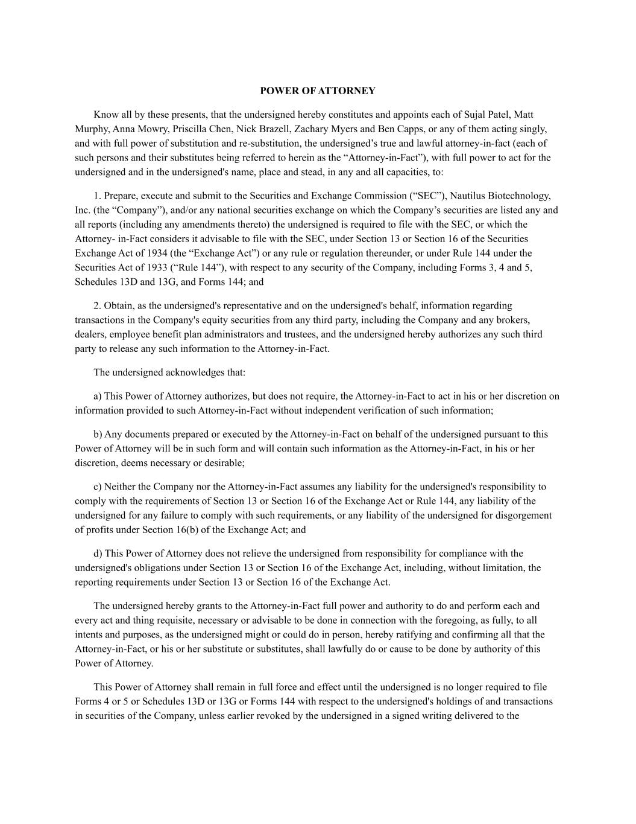
POWER OF ATTORNEY Know all by these presents, that the undersigned hereby constitutes and appoints each of Sujal Patel, Matt Murphy, Anna Mowry, Priscilla Chen, Nick Brazell, Zachary Myers and Ben Capps, or any of them acting singly, and with full power of substitution and re-substitution, the undersigned’s true and lawful attorney-in-fact (each of such persons and their substitutes being referred to herein as the “Attorney-in-Fact”), with full power to act for the undersigned and in the undersigned's name, place and stead, in any and all capacities, to: 1. Prepare, execute and submit to the Securities and Exchange Commission (“SEC”), Nautilus Biotechnology, Inc. (the “Company”), and/or any national securities exchange on which the Company’s securities are listed any and all reports (including any amendments thereto) the undersigned is required to file with the SEC, or which the Attorney- in-Fact considers it advisable to file with the SEC, under Section 13 or Section 16 of the Securities Exchange Act of 1934 (the “Exchange Act”) or any rule or regulation thereunder, or under Rule 144 under the Securities Act of 1933 (“Rule 144”), with respect to any security of the Company, including Forms 3, 4 and 5, Schedules 13D and 13G, and Forms 144; and 2. Obtain, as the undersigned's representative and on the undersigned's behalf, information regarding transactions in the Company's equity securities from any third party, including the Company and any brokers, dealers, employee benefit plan administrators and trustees, and the undersigned hereby authorizes any such third party to release any such information to the Attorney-in-Fact. The undersigned acknowledges that: a) This Power of Attorney authorizes, but does not require, the Attorney-in-Fact to act in his or her discretion on information provided to such Attorney-in-Fact without independent verification of such information; b) Any documents prepared or executed by the Attorney-in-Fact on behalf of the undersigned pursuant to this Power of Attorney will be in such form and will contain such information as the Attorney-in-Fact, in his or her discretion, deems necessary or desirable; c) Neither the Company nor the Attorney-in-Fact assumes any liability for the undersigned's responsibility to comply with the requirements of Section 13 or Section 16 of the Exchange Act or Rule 144, any liability of the undersigned for any failure to comply with such requirements, or any liability of the undersigned for disgorgement of profits under Section 16(b) of the Exchange Act; and d) This Power of Attorney does not relieve the undersigned from responsibility for compliance with the undersigned's obligations under Section 13 or Section 16 of the Exchange Act, including, without limitation, the reporting requirements under Section 13 or Section 16 of the Exchange Act. The undersigned hereby grants to the Attorney-in-Fact full power and authority to do and perform each and every act and thing requisite, necessary or advisable to be done in connection with the foregoing, as fully, to all intents and purposes, as the undersigned might or could do in person, hereby ratifying and confirming all that the Attorney-in-Fact, or his or her substitute or substitutes, shall lawfully do or cause to be done by authority of this Power of Attorney. This Power of Attorney shall remain in full force and effect until the undersigned is no longer required to file Forms 4 or 5 or Schedules 13D or 13G or Forms 144 with respect to the undersigned's holdings of and transactions in securities of the Company, unless earlier revoked by the undersigned in a signed writing delivered to the

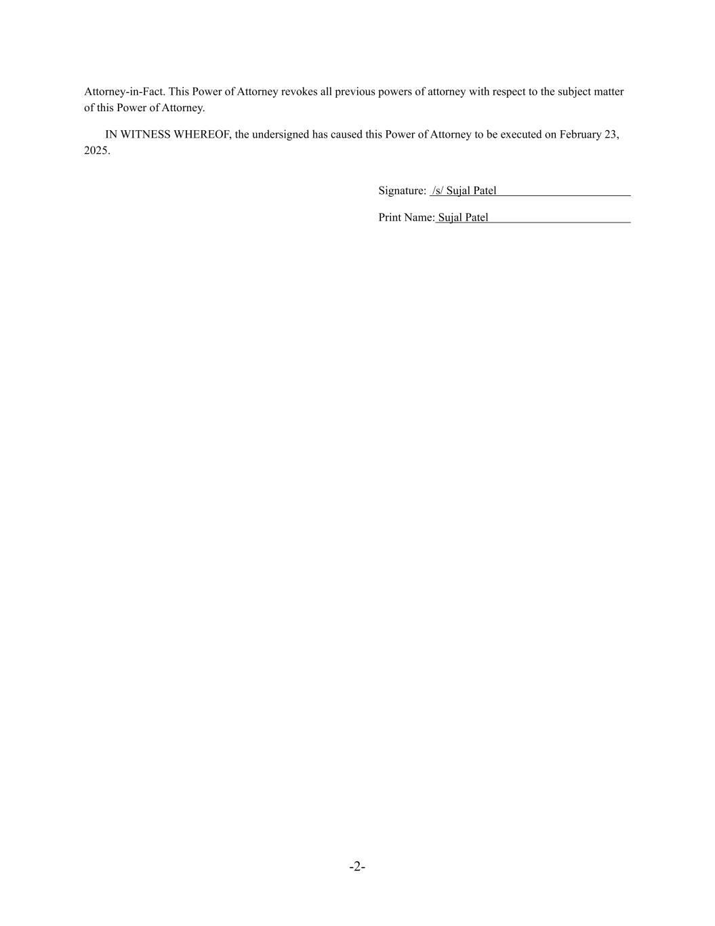
-2- Attorney-in-Fact. This Power of Attorney revokes all previous powers of attorney with respect to the subject matter of this Power of Attorney. IN WITNESS WHEREOF, the undersigned has caused this Power of Attorney to be executed on February 23, 2025. Signature: /s/ Sujal Patel Print Name: Sujal Patel

