UNITED STATES
SECURITIES AND EXCHANGE COMMISSION
Washington, D.C. 20549
_____________________________________________________________________
SCHEDULE 14A
Proxy Statement Pursuant to Section 14(a) of the
Securities Exchange Act of 1934
_____________________________________________________________________
Filed by the Registrant x
Filed by a Party other than the Registrant ☐

Check the appropriate box:
☐ |  |  | Preliminary Proxy Statement
☐ |  |  | Confidential, for Use of the Commission Only (as permitted by Rule 14a-6(e)(2))
☐ |  |  | Definitive Proxy Statement
x |  |  | Definitive Additional Materials
☐ |  |  | Soliciting Material under §240.14a-12
NAUTILUS BIOTECHNOLOGY, INC.
(Name of Registrant as Specified In Its Charter)
(Name of Person(s) Filing Proxy Statement, if other than the Registrant)
Payment of Filing Fee (Check all boxes that apply):
x |  |  | No fee required.
☐ |  |  | Fee paid previously with preliminary materials.
☐ |  |  | Fee computed on table in exhibit required by Item 25(b) per Exchange Act Rules 14a-6(i)(1) and 0-11.

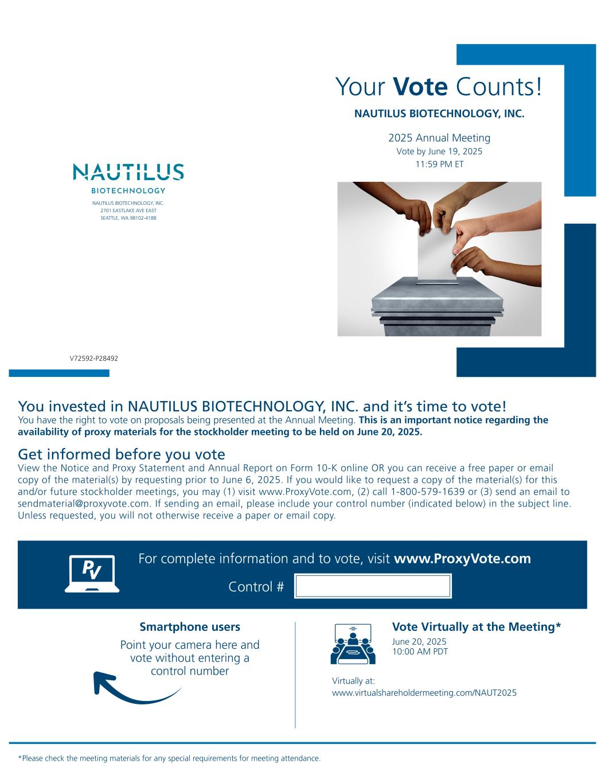

Your Vote Counts! *Please check the meeting materials for any special requirements for meeting attendance. Smartphone users Point your camera here and vote without entering a control number For complete information and to vote, visit www.ProxyVote.com Control # V72592-P28492 NAUTILUS BIOTECHNOLOGY, INC. 2025 Annual Meeting Vote by June 19, 2025 11:59 PM ET NAUTILUS BIOTECHNOLOGY, INC. 2701 EASTLAKE AVE EAST SEATTLE, WA 98102-4188 You invested in NAUTILUS BIOTECHNOLOGY, INC. and it’s time to vote! You have the right to vote on proposals being presented at the Annual Meeting. This is an important notice regarding the availability of proxy materials for the stockholder meeting to be held on June 20, 2025. Vote Virtually at the Meeting* June 20, 2025 10:00 AM PDT Virtually at: www.virtualshareholdermeeting.com/NAUT2025 Get informed before you vote View the Notice and Proxy Statement and Annual Report on Form 10-K online OR you can receive a free paper or email copy of the material(s) by requesting prior to June 6, 2025. If you would like to request a copy of the material(s) for this and/or future stockholder meetings, you may (1) visit www.ProxyVote.com, (2) call 1-800-579-1639 or (3) send an email to sendmaterial@proxyvote.com. If sending an email, please include your control number (indicated below) in the subject line. Unless requested, you will not otherwise receive a paper or email copy.

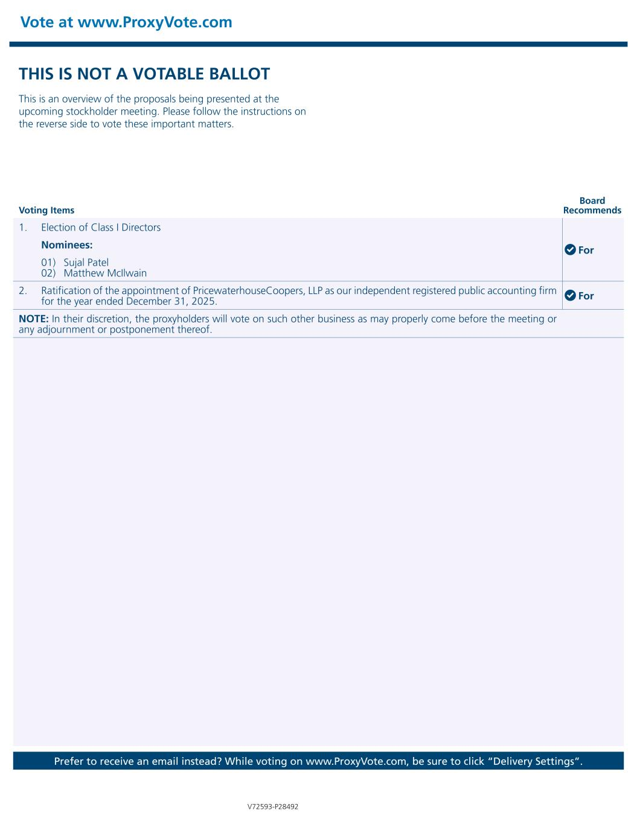
Vote at www.ProxyVote.com Prefer to receive an email instead? While voting on www.ProxyVote.com, be sure to click “Delivery Settings”. Voting Items Board Recommends V72593-P28492 THIS IS NOT A VOTABLE BALLOT This is an overview of the proposals being presented at the upcoming stockholder meeting. Please follow the instructions on the reverse side to vote these important matters. 1. Election of Class I Directors For Nominees: 01) Sujal Patel 02) Matthew McIlwain 2. Ratification of the appointment of PricewaterhouseCoopers, LLP as our independent registered public accounting firm for the year ended December 31, 2025. For NOTE: In their discretion, the proxyholders will vote on such other business as may properly come before the meeting or any adjournment or postponement thereof.

