SEC Form 4

FORM 4

Check this box if no longer subject to Section 16. Form 4 or Form 5 obligations may continue. See Instruction 1(b).

Check this box to indicate that a transaction was made pursuant to a contract, instruction or written plan for the purchase or sale of equity securities of the issuer that is intended to satisfy the affirmative defense conditions of Rule 10b5-1(c). See Instruction 10.

UNITED STATES SECURITIES AND EXCHANGE COMMISSION
Washington, D.C. 20549
Washington, D.C. 20549 |  | OMB APPROVAL
STATEMENT OF CHANGES IN BENEFICIAL OWNERSHIP
STATEMENT OF CHANGES IN BENEFICIAL OWNERSHIP |  | OMB Number: | 3235-0287
 |  | Estimated average burden
Filed pursuant to Section 16(a) of the Securities Exchange Act of 1934 |  | hours per response: | 0.5
or Section 30(h) of the Investment Company Act of 1940
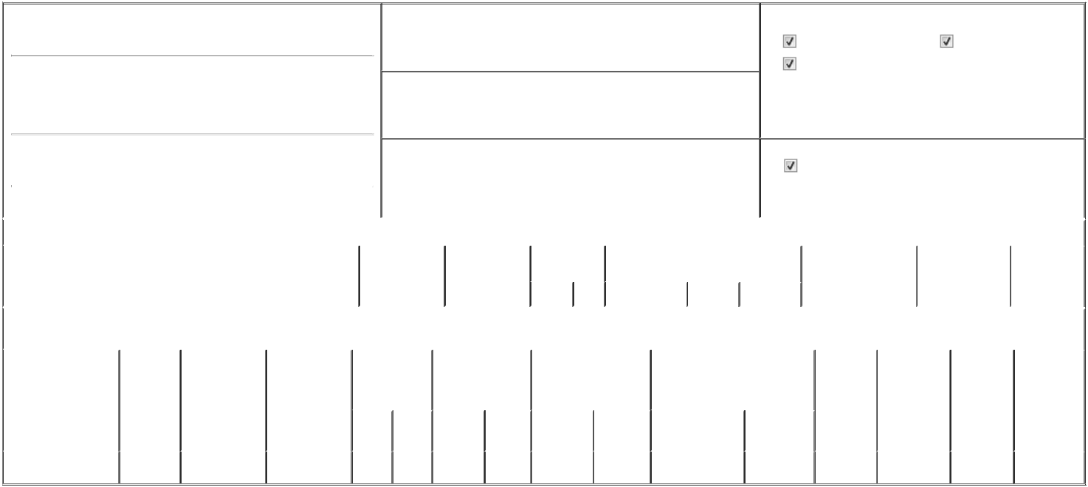

1. Name and Address of Reporting Person*
Mallick Parag

(Last) (First) (Middle)

C/O NAUTILUS BIOTECHNOLOGY, INC.

2701 EASTLAKE AVENUE EAST

2. Issuer Name and Ticker or Trading Symbol

Nautilus Biotechnology, Inc. [ NAUT ]

3. Date of Earliest Transaction (Month/Day/Year)

03/03/2025

- Relationship of Reporting Person(s) to Issuer (Check all applicable)

Director | 10% Owner
Officer (give title | Other (specify below)
below) | Other (specify below)

Chief Scientist

 | (Street) |  |  |  |  |  | 4. If Amendment, Date of Original Filed (Month/Day/Year) |  |  |  |  |  |  | 6. Individual or Joint/Group Filing (Check Applicable Line)
 |  | SEATTLE | WA | 98102 |  |  |  |  |  |  |  |  |  |  |  | Form filed by One Reporting Person
 |  |  |  |  |  |  |  |  |  |  |  |  |  |  |  | Form filed by More than One Reporting Person
 |  | (City) | (State) | (Zip)
 |  |  |  |  | Table I - Non-Derivative Securities Acquired, Disposed of, or Beneficially Owned
 | 1. Title of Security (Instr. 3) |  |  |  |  | 2. Transaction |  | 2A. Deemed |  | 3. Transaction |  | 4. Securities Acquired (A) or Disposed Of |  |  | 5. Amount of Securities |  |  | 6. Ownership |  | 7. Nature of
 |  |  |  |  |  | Date |  | Execution Date, |  | Code (Instr. 8) (D) (Instr. 3, 4 and 5) |  |  |  |  | Beneficially Owned |  |  | Form: Direct (D) or |  | Indirect
 |  |  |  |  |  | (Month/Day/Year) if any |  |  |  |  |  |  |  |  | Following Reported |  |  | Indirect (I) (Instr. 4) |  | Beneficial
 |  |  |  |  |  |  |  | (Month/Day/Year) |  | Code | V | Amount | (A) or (D) | Price | Transaction(s) (Instr. 3 |  |  |  |  | Ownership
 |  |  |  |  |  |  |  |  |  |  |  |  |  |  | and 4) |  |  |  |  | (Instr. 4)
 |  |  |  |  | Table II - Derivative Securities Acquired, Disposed of, or Beneficially Owned
 |  |  |  |  |  | (e.g., puts, calls, warrants, options, convertible securities)
 | 1. Title of Derivative |  | 2. | 3. Transaction | 3A. Deemed | 4. Transaction |  | 5. Number of |  | 6. Date Exercisable and |  |  | 7. Title and Amount of Securities |  |  | 8. Price of | 9. Number of |  | 10. | 11. Nature of
 | Security (Instr. 3) |  | Conversion | Date | Execution Date, | Code (Instr. 8) |  | Derivative |  | Expiration Date |  |  | Underlying Derivative Security |  |  | Derivative | derivative |  | Ownership | Indirect
 |  |  | or Exercise | (Month/Day/Year) | if any |  |  | Securities Acquired |  | (Month/Day/Year) |  |  | (Instr. 3 and 4) |  |  | Security | Securities |  | Form: | Beneficial
 |  |  | Price of |  | (Month/Day/Year) |  |  | (A) or Disposed of |  |  |  |  |  |  |  | (Instr. 5) | Beneficially |  | Direct (D) or | Ownership
 |  |  | Derivative |  |  |  |  | (D) (Instr. 3, 4 and 5) |  |  |  |  |  |  |  |  | Owned |  | Indirect (I) | (Instr. 4)
 |  |  | Security |  |  |  |  |  |  |  |  |  |  |  |  |  | Following |  | (Instr. 4)
 |  |  |  |  |  |  |  |  |  |  |  |  |  | Amount or |  |  | Reported
 |  |  |  |  |  |  |  |  |  | Date |  | Expiration |  | Number of |  |  | Transaction(s)
 |  |  |  |  |  | Code V |  | (A) | (D) | Exercisable |  | Date | Title | Shares |  |  | (Instr. 4)
 | Stock Option (Right to |  | $1.24 | 03/03/2025 |  | A |  | 280,000 |  | (1) |  | 03/03/2035 | Common Stock | 280,000 | $0 |  | 280,000 |  | D
 | Buy) |  | $1.24 | 03/03/2025 |  |  |  | 280,000 |  | (1)

Explanation of Responses:

- 25% of the shares subject to the Option shall vest and become exercisable on the first anniversary of the Vesting Commencement Date, as defined below, and the balance of the shares subject to the Option shall vest and become exercisable on a ratable, monthly basis over the 36 months succeeding such first anniversary so long as the Reporting Person remains a Service Provider as provided in the Issuer's 2021 Equity Incentive Plan. Vesting Commencement Date shall mean January 1, 2025.

Remarks:

/s/ Mathew B. Murphy, as Attorney-in-

Fact

** Signature of Reporting Person

03/04/2025

Date

Reminder: Report on a separate line for each class of securities beneficially owned directly or indirectly.

* If the form is filed by more than one reporting person, see Instruction 4 (b)(v).

- Intentional misstatements or omissions of facts constitute Federal Criminal Violations See 18 U.S.C. 1001 and 15 U.S.C. 78ff(a). Note: File three copies of this Form, one of which must be manually signed. If space is insufficient, see Instruction 6 for procedure.
Persons who respond to the collection of information contained in this form are not required to respond unless the form displays a currently valid OMB Number.



